CSC371: Database Systems

FALL 2020

LAB Project: Development of a database application

In this project, you are going to develop an application of your choice. You are free to develop any application using any platform as long as it meets the following project requirements:

* Your application should have data storage and retrieval requirements
* Your application must use a relational database management system for storage and retrieval of data
* Your application should have enough modules and the associated functionality so that:
* Your ER data model must contain at least 12 entity types
* Your ER diagram’s eventual mapping to relational schema must produce a minimum of 15 tables
* You must use all the basic SQL constructs specifically INSERT, UPDATE, DELETE, JOINS, and Grouping and Aggregation in your application in a meaningful way.
* You must hand over and demonstrate fully functional and database integrated application without errors
* A good interface will yield extra points
* It is an individual project

The project has the following three deliverables:

1. Project Scope Document (Template is provided below)
2. Entity Relationship Diagram
3. Application demonstration along with the well-formatted project report extending the scope document, including the Entity Relationship Diagram, and further discussing the implementation details and issues you faced. It must also include a user manual too.

You must get the previous deliverables approved before proceeding to work on the next one,

Project Proposal

For

Restaurant Management System

Restaurant management System enables easy monitoring of daily activities of restaurant

Submitted by

Muhammad Tufail Ali Chaudhry, SP19-BCS-041

Department of Computer Science, CU, Islamabad.

11/12/2020

**Table of Contents**

Abstract 2

1. Introduction 3

2. Proposed System 3

3. Advantages/Benefits of Proposed System 3

4. Scope 3

5. Modules 3

5.1 Module 1: Cashier Module 4

5.2 Module 2: Manager Module

5.3 Module 3: Customer Module

5.4 Module 4: Bill Module

5.5 Module 5: Waiter Module

5.6 Module 6: Order Module

5.7 Module 7: Chef Module

5.8 Module 8: Item Module

5.9 Module 9: Comment Module

5.10 Module 10: Online Order Module

5.11 Module 11: Seat Reservation Module

6. System Limitations/Constraints 4

7. Tools and Technologies 4

8. Conclusion 5

9. References 5

**Project Category: (**Select the major domain of proposed project**)**

* **A-**Desktop Application/Information System **B-**Web Application/Web Application based Information System

# Abstract

The main goal of this project is to keep the track of daily restaurant activities. It will manages all kind of data. The project is entirely administrative with some access of application available to the cashier, customer and manager. The main and private access are available to the admin so the project is safe and secure. The project aim is to develop an application which minimize the probability of human errors. The application will keep the record of the daily sale and profit earned.

# Introduction

According to a research article written by Horizons, in 2006 within the UK there was just over 26,000 restaurants with 734 million meals served that year. As this restaurant sector was worth £7.61 billion, any restaurant generating a good business reputation could lead to the making of a very successful and proﬁtable business. If restaurant have a good management system so the customers will get attracted to the restaurant and we again visit the restaurant in future. However, if they have to wait for an unreasonable amount of lite or there was a mistake in the order, it’s very unlikely the customer would return.

Therefore a solution to this problem would be to minimize mistake within the order and bill, and also not delay the order placed by the customer. This application will help to achieve these tasks.

# Proposed System

The proposed system will provide an organized way of managing data. It will remove the error of wrong order because in it the customer will place its order on the application and it will also nullify the wrong bill produced because system will calculate the bill and there is no chance of error due to human mistake. Everything is occurring on application so there will be a lot of time saved and this time will be consumed to serve the customer so there will be no delay in the orders also.

# Advantages/Benefits of Proposed System

Following are the advantages of the proposed system

* Time efficient
* Error free
* Safety
* Durable
* Proper detail of every day sale item
* Proper detail of daily profit produced

# Scope

The purpose of this project is to provide ease to the restaurant management. Every activity occurring in restaurant is through this application. The application start when a customer comes to a restaurant. First he will place the order on the application and the bill of this order will goes to the cashier. The cashier will add this amount to the database section to track the record and all this activities are monitored by the administrator.

# Modules

Following are the modules

## Module 1: Cashier Module

In this module the payment paid by the customer is maintained. Cashier can perform three tasks

1. Cashier can add item to record to keep track of record
2. Cashier can view record at any time
3. Cashier can edit the record

## Module 2: Manager Module

In this module the manager can keep the track of all activities occurring in the restaurant and can also manage them. Manager can perform six tasks

1. Manager can add a cashier
2. Manager can remove a cashier
3. Manager can add a waiter
4. Manager can remove a waiter
5. Manager can add a Chef
6. Manager can remove a Chef

## Module 3: Customer Module

In this module a customer can place an order on the application and can also get the bill of order and also bill receipt.

## Module 4: Bill Module

In this bill is generated of the customer order and customer can see the total bill and also bill recipt

## Module 5: Waiter Module

Waiter can be added and removed by the manager.

## Module 6: Order Module

In this module order is given by the customer on the application

## Module 7: Chef Module

Chef can be added and removed by the manager.

## Module 8: Item Module

It contains the items which a restaurant contains and which a customer can order to eat.

## Module 9: Comment Module

This module is not added in the application.

## Module 10: Online order Module

This module is not added in the application.

## Module 11: Seat Reservation Module

This module is not added in the application.

# System Limitations/Constraints

Following are the limitations

* Many order placed at same time
* Internet is required

# Tools and Technologies

Following are the tools and technologies which will be used.

Table 1 Tools and Technologies for Proposed Project

|  |  |  |  |
| --- | --- | --- | --- |
| **Tools**  **And**  **Technologies** | **Tools** | **Version** | **Rationale** |
| netbeans | 2020 | IDE |
| MS SQL Server and XAMPP | 2015 | DBMS |
| Adobe Photoshop | 2020 | Design Work |
| MS Word | 2015 | Documentation |
| Adobe illustrate | 2019 | Design Work |
| **Technology** | **Version** | **Rationale** |
| SQL | 2013 | Query Language |
| java | 14 | Programming Language |

# Conclusion

Today in world time is everything and have great importance. This application will help to save time both of customer as well as of restaurant management.

# References

Following are the references

<https://www.rancelab.com/blog/tag/advantages-and-disadvantages-of-restaurant-business/>

**Entity Relationship Diagram:**

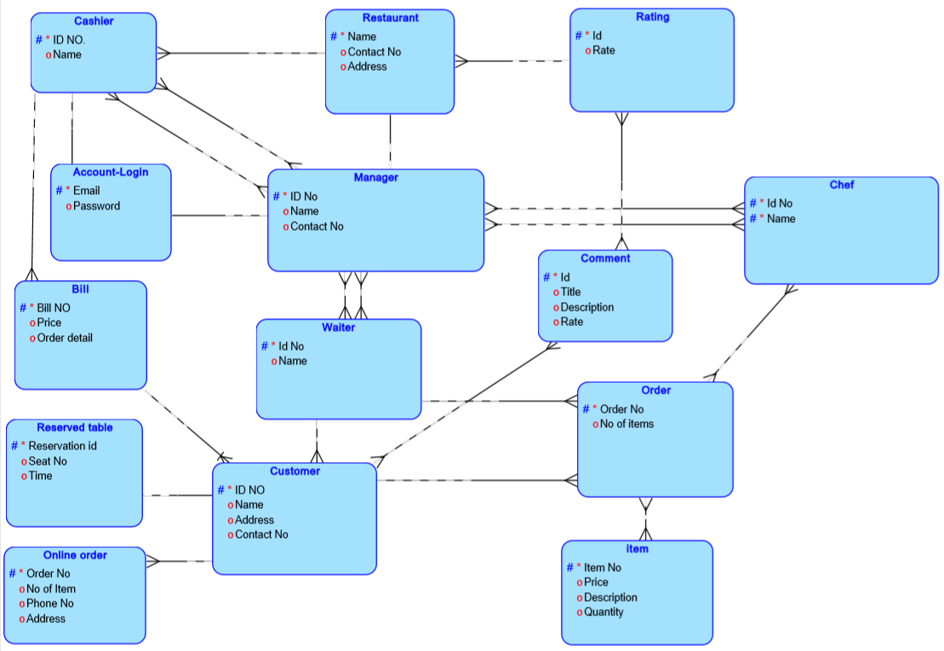

**User manual**

There are three user of the application

1. Manager
2. Cashier
3. Customer

**1) Manager:**

First the welcome screen will appear. When manager select manager button then the manager login page will appear. Manager will login using his username and password. After login Manage Module page will appear in which manager can do six things

1. Manager can add a cashier
2. Manager can remove a cashier
3. Manager can add a waiter
4. Manager can remove a waiter
5. Manager can add a Chef
6. Manager can remove a Chef

**ADD CASHIER:**

If manager click add cashier than add cashier page will appear in which manager have to put four information.

1. Cashier’s ID
2. Cashier’s Name
3. Cashier’s Salary
4. Cashier’s Rank

After putting these information manager can add that cashier by clicking add.

**Fire CASHIER:**

If manager click fire cashier than fire cashier page will appear. To fire a cashier first manager have to know whom he want to fire to know this manager will click on view record. Record of all cashier will appear after knowing the cashier whom he want to fire manager just write cashier id on fire field and then press fire to fire that cashier.

**ADD WAITER:**

If manager click add waiter than add waiter page will appear in which manager have to put four information.

1. Waiter’s ID
2. Waiter’s Name
3. Waiter’s Salary
4. Waiter’s Rank

After putting these information manager can add that waiter by clicking add.

**Fire WAITER:**

If manager click fire waiter than fire waiter page will appear. To fire a waiter first manager have to know whom he want to fire to know this manager will click on view record. Record of all waiter will appear after knowing the waiter whom he want to fire manager just write waiter id on fire field and then press fire to fire that waiter.

**ADD CHEF:**

If manager click add chef than add chef page will appear in which manager have to put four information.

1. Chef’s ID
2. Chef’s Name
3. Chef’s Salary
4. Chef’s Rank

After putting these information manager can add that chef by clicking add.

**Fire CHEF:**

If manager click fire chef than fire chef page will appear. To fire a chef first manager have to know whom he want to fire to know this manager will click on view record. Record of all chef will appear after knowing the chef whom he want to fire manager just write chef id on fire field and then press fire to fire that chef.

**2) Cashier:**

First the welcome screen will appear. When cashier select cashier button then the cashier login page will appear. Cashier will login using his username and password. After login Cashier Module page will appear in which manager can do three things

1. Cashier can add item to record to keep track of record
2. Cashier can view record at any time
3. Cashier can edit the record

**Add item to record:**

If cashier click on Add item to record than ADD ITEM page will appear in which cashier have to put three information

1. Item No
2. Item
3. Price

After putting these information cashier can add item to the record

**View Record:**

If cashier click on View Record than View Detail page will appear. If cashier want to see the detail of the record then he will just have to click VIEW RECORD button than all record of items will get appeared.

**Edit record:**

If cashier click on Edit Record than Edit Record page will appear in which cashier have to put three information

1. Item No (The item which he wants to edit)
2. Item (The item which he wants to add)
3. Price (Price of new item)

After putting these information cashier can edit item in record

**3) Customer**

First welcome screen will appear customer have to click customer button to go to menu and order placement page. After clicking customer button Customer Module System page will appear. In it there are item which a customer can order. Customer just have to put quantity of the item he wants to buy after putting the order customer click on total to know the total bill of the order. He can also click on receipt to get the receipt of the order. If a customer place a wrong quantity so he can also reset the order and there is also option to exit customer module system.

**Problem faced:**

The problem I faced is while putting the image on the background of the application.

The problem is with layout. It tried three layout

1. Free layout
2. Null layout
3. Absolute layout

**Free layout:**

In free layout the window of application will appear correctly but while seeing the design some field and button will get disappear which is shown in below picture.

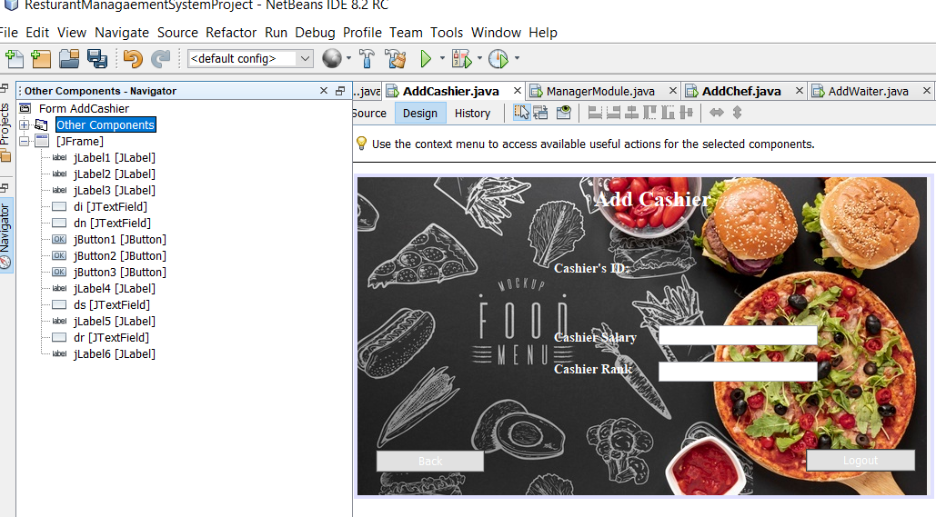

**Null layout:**

In null layout all the field and button appears in design but when we run application the application is in minimized form and we have to maximize it which is really annoying the problem is shown in below picture

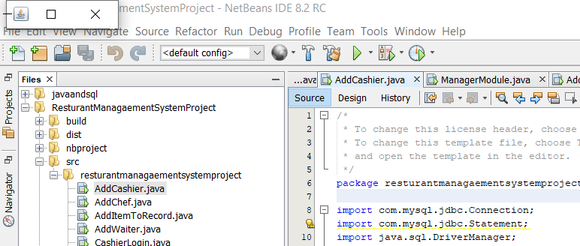

**Absolute layout:**

I used absolute layout in it application window appear correctly when we run application the only problem with it is we can only see half of screen in design which is shown below in picture.

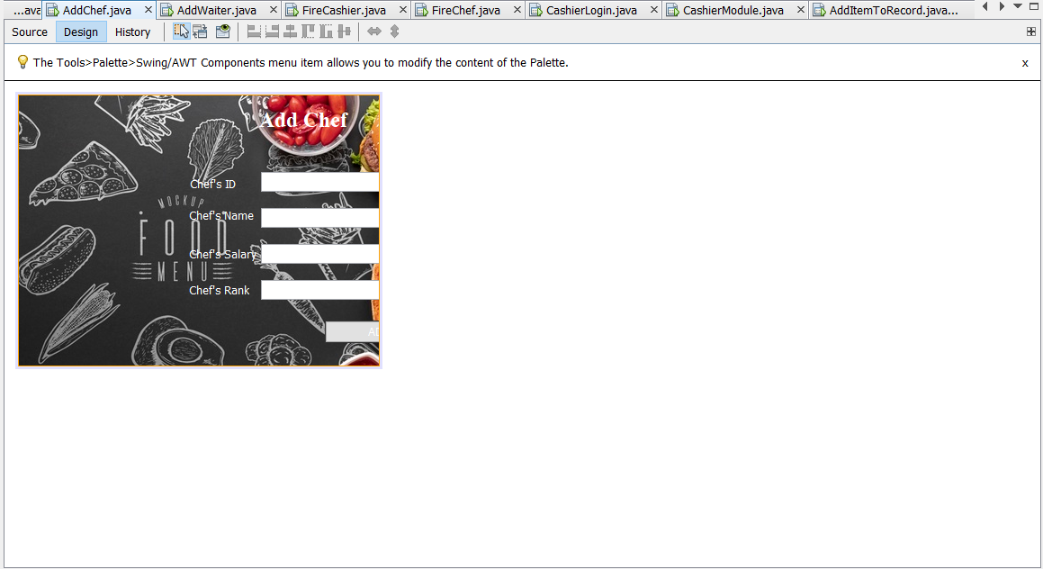

But we can resolve it by dragging it. Like shown in figure

